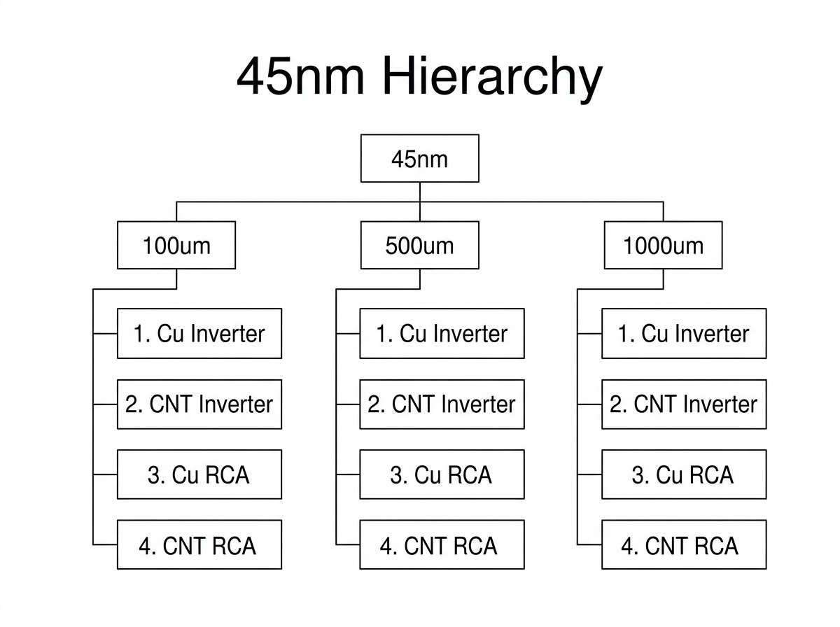

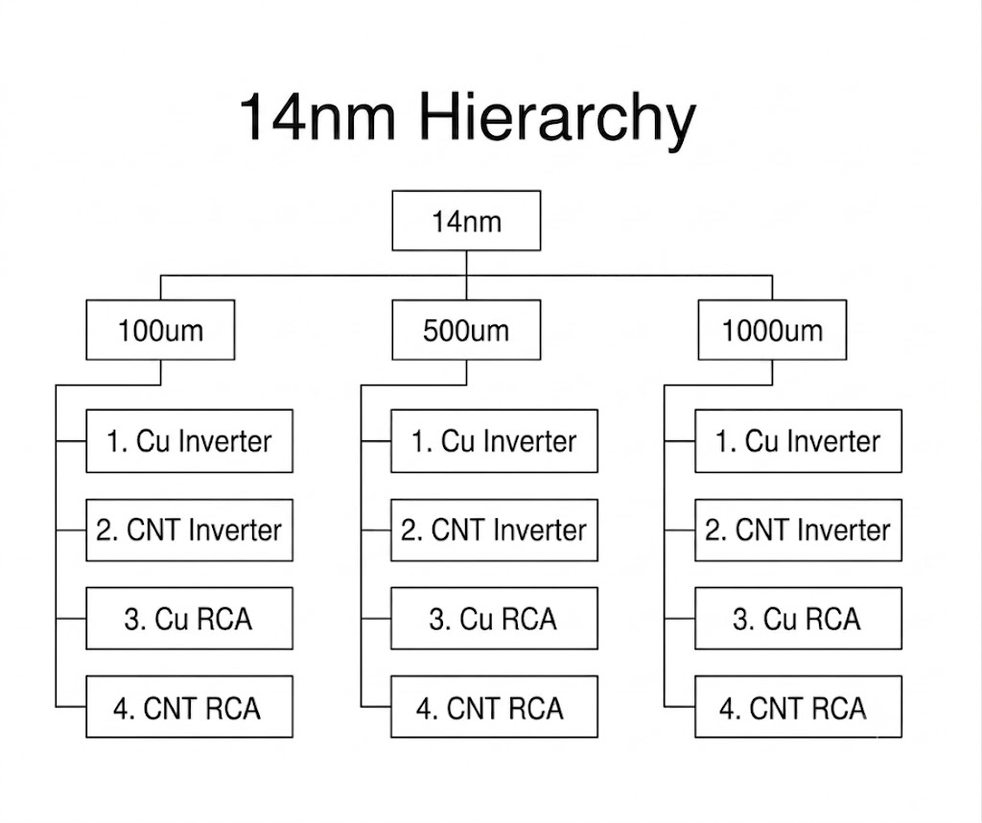

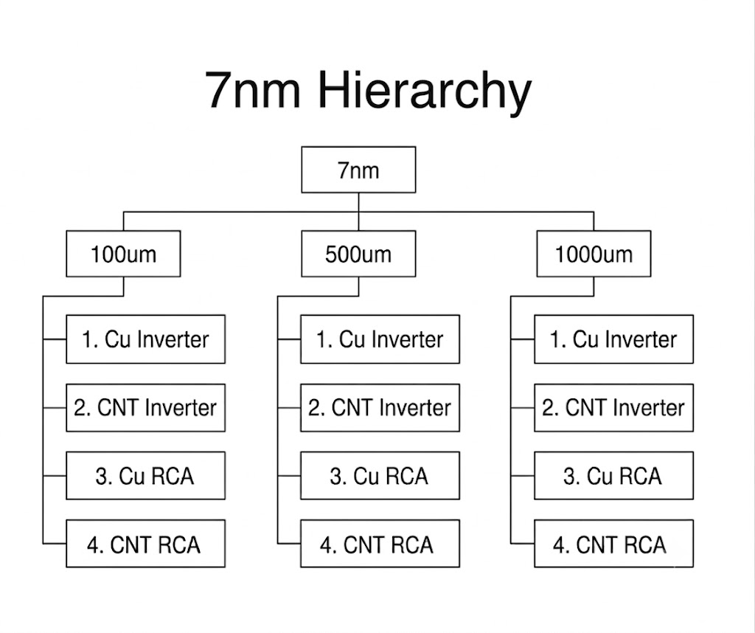

1. Cu Inverter
- Run the simulation.
- Right-click on the black waveform area.
- Select Add Traces...
- Add:
  - V(in)
  - V(mid)
  - V(in2)
  - V(out)
- Click OK.

2. CNT Inverter
- Run the simulation.
- Right-click on the black waveform area.
- Select Add Traces...
- Add:
  - V(in)
  - V(mid)
  - V(in2)
  - V(out)
- Click OK.

3. Cu 4-bit RCA
- Run the simulation.
- Right-click on the waveform area.
- Select Add Traces...
- Add:
  - V(n_c1_raw)
  - V(c1)
- Click OK.
Then create the second plot:
- Right-click on the waveform area again.
- Select Add Plot Pane Below.
- In the new bottom pane, right-click.
- Select Add Traces...
- Add:
  - V(s0)
  - V(s1)
  - V(s2)
  - V(s3)
  - V(cout)
- Click OK.
- Go to View → SPICE Error Log.
- Find tpd_int1 and record the value.

4. CNT 4-bit RCA
- Run the simulation.
- Right-click on the waveform area.
- Select Add Traces...
- Add:
  - V(n_c1_raw)
  - V(c1)
- Click OK.
Then:
- Right-click on the waveform area again.
- Select Add Plot Pane Below.
- In the new bottom pane, right-click.
- Select Add Traces...
- Add:
  - V(s0)
  - V(s1)
  - V(s2)
  - V(s3)
  - V(cout)
- Click OK.
- Go to View → SPICE Error Log.
- Find tpd_int1 and record the value.

